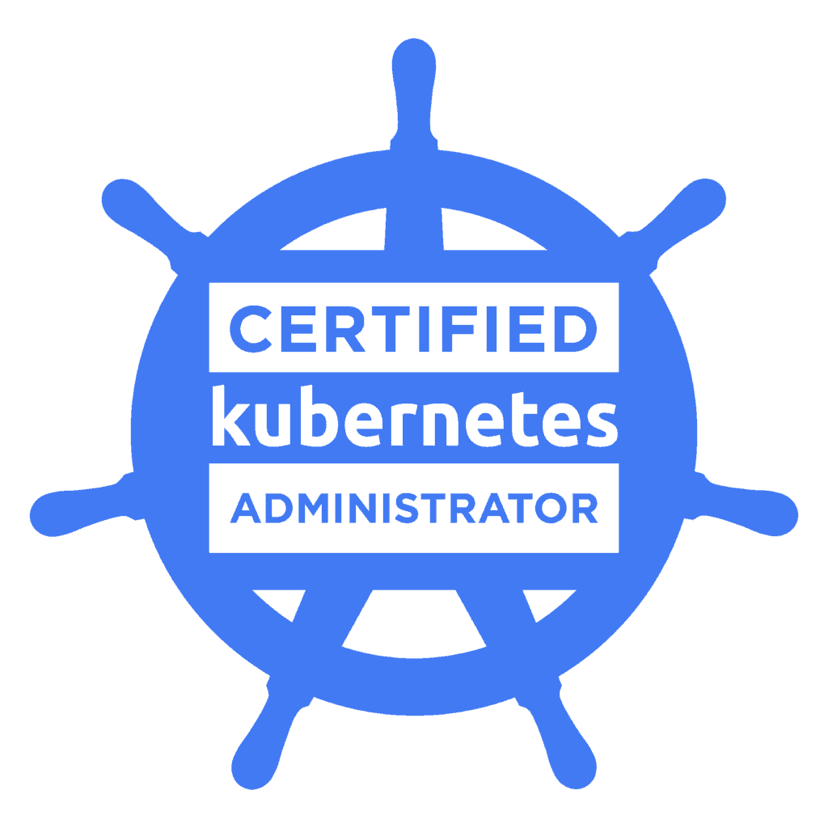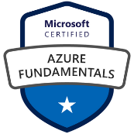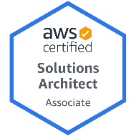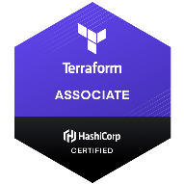**Venkata G**

Senior DevOps Engineer / Senior Cloud Engineer

**Contact** : +1 (678) 306-6083 , gvenkata967@gmail.com

**LinkedIn** : linkedin.com/in/venkata-g-107b65232

**Professional Summary:**

* 8+ years of experience in DevOps, Configuration Management, Build Engineering and Release Management processes, including building binaries, end-to-end code configuration, and deployments of artifacts for entire life cycle model in Enterprise Applications.
* Implemented high availability with Azure Classic and Azure Resource Manager deployment models.
* Leveraged infrastructure as code (IAC) using Azure ARM templates (Infrastructure as code, JSON / YAML config).
* Developed microservice on boarding tools leveraging Python and Jenkins allowing for easy creation and maintenance of build jobs and Kubernetes deploy and services.
* Experience with installation, configuration and maintenance in CI technologies like Jenkins/Hudson performing end to end automation for builds and deployments.
* Experience with Azure transformation projects and Azure architecture decision making Architect and implement ETL and data movement solutions using Azure Data Factory(ADF).
* Developed automation scripting in Python (core) using Puppet to deploy and manage Java applications across Linux servers.
* Experience in Migration & deployment of Applications with upgrade version of Application & Hardware, MS build, batch script and Jenkins Administrator.
* Managed Amazon Web Services like EC2, S3 bucket, RDS, EBS, ELB, Auto-Scaling, AMI, IAM through AWS Console and API Integration with Puppet Code.
* Plan and Develop roadmaps and deliverables to advance the migration of existing solutions on-premise systems/applications to Azure cloud.
* Extensive experience using MAVEN and ANT as build tools for the building of deployable artifacts (jar, war & ear) from source code.
* Worked on deployment automation of all the micro services to pull image from the private docker registry and deploy to docker swarm cluster using Ansible.
* Extensive experience in using Build Automation tools like, ANT, Maven. Understanding of Cloud Environment like AWS, Azure, PCF Pivotal Cloud Foundry.
* Knowledge on various Docker components like Docker Engine, Hub, Machine, Compose and Docker Registry. Experience with container based deployments using Docker, working with Docker images, Docker hub and Docker registries.
* Developed automation scripting in Python (core) using Chef to deploy and manage applications across Linux servers.
* Creating Ansible Playbooks, to Deploy VM and install the Components as per requirements.
* Exposed to all aspects of software development life cycle (SDLC) such as Analysis, Planning, Testing, and Implementing, Post-production analysis of the projects.
* Skilled in supporting WebSphere, WebLogic, and JBoss application Server. Focused on containerization and immutable infrastructure.
* Ability to build automated scripts and coordinate with the software development team for comprehensive knowledge of software development life cycle.
* Good knowledge in managing Nexus and Artifactory repositories for the maven artifacts and dependencies.
* Hands-on on Ansible and Ansible Tower as Configuration Worked on container based technologies like Docker, OPENSHIFT and Kubernetes.
* Automate repetitive tasks, quickly deploy critical applications, Environment configuration Files, Users, Mount points, Packages and proactively manage change and written Ansible Playbooks using Yaml for Maintaining Roles, Inventory Files and Groups Variables.
* Deploy Openstack environments through automated tools, Ansible / custom pipeline.
* Experience in working with continuous integration using Jenkins, TeamCity and Hudson.
* Managed all the bugs and changes into a production environment using the Jira tracking tool.
* Involved in setting up JIRA as defect tracking system and configured various workflows, customizations and plugins for the JIRA bug/issue tracker.
* Create multiple groups and set permission polices for various groups in AWS.
* Designed Network Security Groups (NSGs) to control inbound and outbound access to network interfaces (NICs), VMs and subnets.
* Experience in creating the ECS Cluster (Elastic Container Service) to spin up the services in the AWS using Terraform.
* Responsible for migrating Cloud Formation Template stack to Terraform and Integrated with EFK to send logs.
* Good understanding of Software Development Life Cycle(SDLC) like Agile, Waterfall Methodologies.

**Technical Skills:**

|  |  |
| --- | --- |
| Hardware / Platforms | HP-UX, Solaris, Ubuntu, RedHat Linux and Windows |
| Version Control Tools | GIT-STASH, Subversion, UCM Clear Case, Harvest Release  12, TFS 2010, Git |
| Programming /Scripting Languages | Shell / Bash Scripting, PERL Scripting, Python, Groovy, YAML, JSON, Java |
| Change Management & Defect Tracking Tools | HP ALM, IBM Rational ClearQuest, BMC Remedy 7, Jira |
| Build Management Tools | Make, GMake, Maven, Ant and MS Build |
| CI/CD Tools | Jenkins, Hudson, Team City, CircleCI and Bamboo |
| DevOps Tools | Ansible, Artifactory, Jenkins, Docker, Docker Swarm, Chef,  Nagios, Git, GitHub, Splunk, Gradle, Vagrant, Puppet,  Kubernetes, Open Source Tripwire & Bamboo |
| Application Server | Apache Tomcat, Apache Geronimo, JBoss Enterprise & IBM  WebSphere |
| Cloud Platforms | Microsoft Azure, Amazon Web Services (AWS) |

**Certifications:**

* Microsoft Certified: DevOps Engineer Expert.
* Microsoft Certified: Azure Fundamentals.
* Hashicorp Certified Terraform Associate
* AWS (Amazon Web Services) Certified Sys-Ops Administrator- Associate.
* CKA (Certified Kubernetes Administration.

**Work Experience:**

Client: Delta Airlines, Atlanta, GA Dec 2020 - Present

Role: Senior DevOps Cloud Engineer

* Developed automation scripting in Python (core) using Puppet to deploy and manage Java applications across Linux servers.
* Handled Docker Engine, Docker-Hub, Docker Compose, Docker Registry, Docker Swarm and Orchestration tools such as Kubernetes. Responsible for container creation and management for different applications on Docker engine through writing and editing Docker files.
* Configured Azure web apps, Azure App services, Azure Application insights, Azure Application gateway, Azure DNS, Azure Traffic manager, App services.
* Involved with Docker and Kubernetes on multiple cloud providers, from helping developers build and containerize their application using Azure Build & Release Pipelines (CI/CD) to deploying either on public or private cloud.
* Designed Network Security Groups (NSGs) to control inbound and outbound access to network interfaces (NICs), VMs and subnets.
* Design and implement end-to-end data solutions (storage, integration, processing, visualization) in Azure.
* Design & implement migration strategies for traditional systems on Azure (Lift and shift/Azure Migrate, other third-party tools) worked on Azure suite: Azure SQL Database, Azure Data Lake(ADLS), Azure Data Factory(ADF) V2, Azure SQL Data Warehouse, Azure Service Bus, Azure key Vault, Azure Analysis Service(AAS), Azure Blob.
* Configured applications on Docker applications by utilizing Docker Compose tool which uses a file configured in YAML format. Used Kubernetes to manage containerized applications using its nodes, Config-maps, Selector, Services, and deployed application Containers as pods.
* Created, managed and performed container based deployments using Docker images containing Middleware and Applications together.
* Worked with Docker to package an application with all its dependencies into a standardized unit for Software Development.
* Worked on Maven to create artifacts from source code and deploy them in Nexus central repository for internal deployments.
* Development of automation of Kubernetes clusters with Ansible, writing playbooks.
* Responsible for watching alerts from Prometheus about kubernetes nodes, disk usage, memory, app restarts and different alerts and responsible for troubleshooting them.
* Migrating the existing project to Microsoft Azure with Azure services. Supports JIRA, Fisheye, and Crucible and the integration of these products with Subversion.
* Integration with Splunk for API traffic monitoring and health checks.
* Worked with Ansible playbooks for orchestration, provisioning, configuration management and application development on LAMP stack.
* Worked on Design and Automation of uDeploy Application process, component process, Environment resources model and designed uDeploy Processes that deploys multiple applications using WAS, JBOSS, DM-Server Containers across both virtual and bare-metal environments.
* Integrated SonarQube with Jenkins for continuous inspection of code quality and analysis with SonarQube scanner for Maven.
* Configured groovy script, shared Jenkins libraries and multi-branch pipeline to handle automated deployment for DEV, INT, UAT, TRN and PROD environment.
* Used Ansible for configuration management and deployed all the services on to the cloud using Ansible.
* Implementing new projects builds framework using Jenkins & maven as build framework.
* Implementing a Continuous Delivery framework using Jenkins, Chef, Maven & Nexus in Linux environment
* Automate Application Delivery using Chef and Urban Code Deploy tool suite.
* Setting up continuous integration and formal builds using Bamboo with Artifactory repository.
* Lead transition from manual configuration and deployment to ‘infrastructure as code’ using Chef, including design and implementation of cookbooks and tooling
* Migration of on premise data (Oracle/ SQL Server/ DB2/ MongoDB) to Azure Data Lake Store (ADLS) using Azure Data Factory (ADF V1/V2)
* Built and managed a large deployment of RedHat Linux instances systems with Chef Automation and
* Integration of Maven/Nexus, Jenkins, Urban Code Deploy with Patterns/Release, Git, Confluence, JIRA and Cloud Foundry
* Worked on GIT repository as Distributed Version Control System. Also, on TFS repository as Centralized Control System.
* Involved in configuring Elastic Load Balancers with Auto scaling to handle high traffic loads.

**Environment:** Azure, Azure DevOps, VMware, Windows, Tomcat Apache, Git, Azure Cloud, Ansible Linux, Jenkins, Python, Maven, Docker, WebLogic, ASB/Mule, F5, Nexus, Splunk, UNIX, Tomcat, Puppet, Jasper Server, Chef Service-Now, Hip Chat, Jabber, Windows, RHEL, Oracle Exa-data, LDAP, Shell script, Kubernetes, Docker.

Client: JM Family Enterprises, Deerfield Beach, FL Aug 2019 – Dec 2020

Role: Cloud / DevOps Engineer

* Designed, configured and deployed Azure Automation Scripts for a many applications utilizing the Azure stack (Including Compute, Web & Mobile, Blobs, ADF, Resource Groups, HD Insight Clusters, Azure SQL, Cloud Services, and ARM), Services and Utilities focusing on Automation.
* Provisioning Azure resources of different providers Compute, Network, Service Fabric, using ARM template and implemented and maintained dev, test, staging and production environments
* Creation of Subnets and Route tables, Internet gateway, Virtual gateway and Customer gateway.
* Setup Chef Server, workstation, client and wrote scripts to deploy applications.
* Deployed the applications to Tomcat Application Server and static content to Apache web servers.
* Moved all pipeline-dependent files from TFVC branches and into Git repository that contains the pipeline script.
* Configure build scripts (ANT) for build Jobs and create, configure nodes on Jenkins.
* Create proof of concepts of technologies to evaluate: Docker, Kubernetes, Cassandra, Bamboo, Jenkins, Splunk, Terraform.
* Worked on creating and implementing CI/CD pipeline using Jenkins, Hudson, Team city and Bamboo for continuous integration and for End to End automation for all build and deployments. configured Plugins for GIT Repository, Maven-Docker plugin, Setup SCM Polling for continuous Build with Maven Repository and Deployed Applications using YAML files through Ansible playbooks as a CI/CD Process.
* Worked on the PowerShell Script to automate the Windows patching and created the release in Azure DevOps pipelines.
* Developed microservice on boarding tools leveraging Python and Jenkins allowing for easy creation and maintenance of build jobs and Kubernetes deploy and services.
* Proposed, Implemented and maintained New Branching strategies for development teams to support trunk, development baseline codes along with several feature branches.
* Worked on Apache and Firewalls in both development and production.
* Deployed and configured Atlassian Jira, both hosted and local instances for issue tracking, workflow collaboration, and tool-chain automation.
* Developed Puppet modules to automate deployment, configuration, and lifecycle management of key clusters. 24/7 monitoring the Azure Resources using Azure Monitor and Web Apps for Application Insights.
* Used Jenkins pipelines to drive all microservices builds out to the Docker registry and then deployed, created pods and managed using Kubernetes.
* Performed merging and tagging need to be done after the code went live in environment.
* Maintain a Live Like environment to test any production issues on the setup and push it into production.
* Responsible for Continuous Integration (CI) and Continuous Delivery (CD) process implementation-using Jenkins along with Python and Shell scripts to automate routine jobs.
* Create and setup automated nightly build environment for java projects using maven.
* Build scripts using ANT and MAVEN build tools in Jenkins to move from one environment to other environments.
* Worked on various Docker components like Docker Engine, Hub, Machine, Compose and Docker Registry.
* Defined and Implemented Software Configuration Management Standards based on Agile/Scrum methodologies, in line with the organization.
* Implemented docker-maven-plugin in maven pom to build docker images for all microservices and later used Docker file to build the docker images from the java jar files.
* Worked with a complex environment on Ubuntu Linux and Windows Servers while ensuring that the systems adhere to organizational standards and policies.
* Worked with a scripting language like Bash, Perl and Ruby and used MySQL, Dynamo DB and Elastic cache to perform basic database administration.
* Kubernetes is being used to orchestrate the deployment, scaling and management of Docker Containers.
* Created Cloud Watch alerts for instances and using them in Auto-scaling launch configurations.

**Environment:** Apache, Tomcat, Nagios, MySQL, Kubernetes, Jenkins, Maven, Azure, Ansible, Docker, Puppet, JBOSS, JSON, Web Logic Application Server, Chef, GIT, Oracle, Windows, and Linux.

Client: Nvent Technologies, Houston, TX Feb 2018 – Aug 2019

Role: DevOps Engineer

* Created the automated build and deployment process for application, re-engineering setup for better user experience, and leading up to building a continuous integration system.
* Created Snapshots and Amazon Machine Images (AMI's) of EC2 Instance for snapshots and creating clone instances. Used Puppet and Chef for Configuration Management tool.
* Configured & deployed Java applications on Amazon Web Services (AWS) for a multitude of applications utilizing the AWS stack, cloud formation.
* Managed Docker orchestration and Docker containerization using Kubernetes.
* Created documents on build and release process and flow, release processes, order of activities for all releases, user guide for developers for local builds.
* Worked on creating and implementing CI/CD pipeline using Jenkins, Hudson, Team city and Bamboo for continuous integration and for End to End automation for all build and deployments. Deployed Applications using YAML files through Ansible playbooks as a CI/CD Process.
* Responsible for Continuous Integration (CI) and Continuous Delivery (CD) process implementation-using Jenkins along with Python and Shell scripts to automate routine jobs.
* Involved in project setting up build using Ansible.
* Maintained the user accounts IAM Roles, VPC, RDB, Dynamo DB, SES, SQS and SNS services in AWS cloud.
* Experience with container-based deployments using Docker, working with Docker images, Docker Hub and Docker-registries and Kubernetes.
* Configured AWS-EC2 Cloud Instances by configuring AMIs using Packer and launched instances with respect to specific applications
* Created and managed a Docker deployment pipeline for custom application images in the cloud using Jenkins.Implemented Chef to deploy the builds for Dev, QA and production.
* Integrated Jenkins with Github for continuous integration and deployment of the code by enabling Git hooks, the build jobs is automatically created once the changes are made to the code by development team.
* Created multi branch pipeline and shared pipeline libraries that can be used by others jobs, created Artifacts and Fingerprints of the build jobs.
* Developed and maintained in-house Code review system before migrating to the lightweight code review system available in Stash.
* Managed Docker- docker hub, pulling images from docker hub, running containers based on an image, creating Dockerfile to manage customized containers, exposing a container with port redirect, container volume management.
* Utilized Kubernetes for the runtime environment of the CI/CD system to build, test deploy.
* Designed and implemented the backup strategy for all the critical systems such as build machines, bug tracking tools, central repositories etc.
* Continuous Integration: implemented and promoted use of Jenkins within the developer community. Validated Jenkins along with Bamboo.
* Changing the AWS infrastructure Elastic Beanstalk to Docker with kubernetes.
* Developed scripts for executing validation/test cases automatically after builds.
* Developed and maintained in-house Code review system before migrating to the lightweight code review system available in Stash.
* Administered and Implemented Jenkins for automated builds.
* Used ANT and MAVEN as build tools on Java projects for the development of build artifacts on the source code.
* Create, maintain and customize complex JIRA project configurations including workflows, custom fields, permissions and notifications.

**Environment:** Java, AWS, Eclipse, Tomcat, Ansible, kubernetes, Apache, Chef, Oracle 11g, Jenkins, Python, JIRA, Maven, Git, Windows, Ruby, Chef, Windows.

Client: Visionyle Solutions, India May 2015 – Oct 2016

Role: Build and Release Engineer

* Installation, Configuration & Upgrade of Solaris, AIX, Linux, and Windows-NT operating systems with installation of Packages and Patches.
* Responsible for automated Scheduled Builds/Emergency Builds and Release using ANT scripts for Enterprise application and wrote build.xml and Pom.xml for applications that use Ant and Maven for builds respectively.
* Deployed and configured Git repositories with branching, forks, tagging, and notifications. Experienced and proficient deploying and administering GitHub.
* Disk and File system management through Verities Volume Manager, LVM and SVM, Database Backup and Recovery Performance Monitoring and Tuning.
* Used Cloud Watch for monitoring AWS cloud resources and the applications that deployed on AWS by creating new alarm, enable notification service.
* Experience with Virtualization technologies like Installing, Configuring, and Administering VMware ESX/ESXi. Created and managed VMs (Virtual Server) and involved in the maintenance of Virtual Servers.
* Installed Management Server (Vcenter Server) instances to enable centralized management of multiple ESXi hosts. Linked different Vcenter servers using linked mode to have a single instance of vSphere client to manage the whole Virtual environment.
* Created deployment request tickets in Remedy for the deploying the code to Production.
* Attended the Minor/Major Event change control meetings to get necessary approvals for the deployment request.
* Onboarding new/existing application logs in Splunk by writing configurations files and maintaining them.
* Automation around Splunk configuration deployment from Perforce & Splunk onboardings using BladeLogic.
* Installed various WebSphere & WebLogic products using shell scripts.
* Installed FixPacks for WAS and cumulative fixes for Portal using CLI and automation.
* Lead WebSphere Portal Admin projects and provide L3 support for apps running on multiple Virtual Portals.
* Used AWS Lambda to manage the servers and run the code in the AWS.
* Deployed and configured various WebSphere Portal artifacts using Console/xmlaccess/ConfigEngine.
* Configured jobs and deployed various middleware artifacts using Devops tools like Jenkins.
* Configured and maintained AWS VPC with services like Route53, ELB, Subnet and NACLs.
* Developed shell scripts for monitoring processes and VM health.
* Deployed various WebLogic, Portal, WAS and DB artifacts via Jenkins.
* Created Modules and Manifests for Puppet on Linux infrastructure updates.
* Worked on capacity planning and increased system resources like CPU, memory, more nodes/JVM's using IBM PureApp console.
* Used Perl/Shell to automate build and deployment Process.
* Documented the deployment process (Migration Doc) of code to production. Used JIRA as Issue Tracking Tool.

**Environment:** Java, Jenkins, AWS, Maven, Linux, Puppet, JIRA, Perl/Shell, UNIX, Linux, GIT, Tomcat.

Client: Gland Pharma, Hyderabad, India July 2012 – May 2015

Role: Linux/System Admin

* Extensive knowledge of common protocols such as SNMP, HTTP, HTTPS, SMTP, NTP, DNS, TCP/IP, and FTP.
* Building servers with Jumpstart / Kickstart, CD on timely basis, along with corporate wide requirements.
* Proactively monitor production database tablespaces, instance, alert log, etc by utilizing Cron joband Linux bash script.
* Installed and configured Linux virtual machines, standalone servers for various applications via kick start, PXE.
* Handled DCR (Defect Change Request), MR (Maintenance Request) using JIRA for change control and ticketing.
* Generated scripts in Maven, Perl, Ruby, and Python& Bash Shell for build activities in QA, Staging and Production environments.
* Perform both interactive and automated (Kickstart) installations of Red Hat Enterprise Linux. Plan and execute RPM and YUM packages and update installations necessary for optimal system performance.
* Viewing and controlling the Processes running on the system and automating repetitive tasks. User Administration by creating, maintaining User's accounts and groups, setting up User environments.
* Managed Disk using LVM, resized disk space when required. Managed disk space from NetApp filers.
* Troubleshoot Backup and Restore Problems, Creation of LVMs on SAN using Linux utilities.
* Monitored overall system performance, performed user management, system updates and disk & storage management. Scanning LUNs from SAN and creating Volume groups, creating and extending LVM and file systems online.
* Created users, manage user permissions, maintain User and File system quota on Linux servers.
* Experience managing and tuning MySQL and writing SQL scripts.
* Created virtual server on VMware ESX/ESXi and Oracle Virtual box based host and installed operating system on guest Servers.
* Experience in writing UNIX shell scripts using commands like awk, sed, tcsh, bash, ksh and perl to automate system admin jobs. Responsible for the operation, maintenance and integrity of a distributed, networked based environment.
* Responsible for Project Management in Linux/Unix/Windows system integration projects
* Designed and Implemented, Administered, Secured Ubuntu, Centos virtual systems and configured related tasks like installations etc.
* Maintained both the servers VM based and standalone and managed updates for Linux and Windows systems.

**Environment:** RHEL, CentOS, Shell Scripting, Python, Bash, Samba, VMware, LDAP, DNS, Samba, FTP, NFS, MYSQL, HTTP, DHCP, SSH, VMware